**Data Loading (Synapse)**

Open your Azure Synapse Workspace 🡪Data Tab 🡪 +SQl database🡪 Serverless 🡪Give a name and create the database

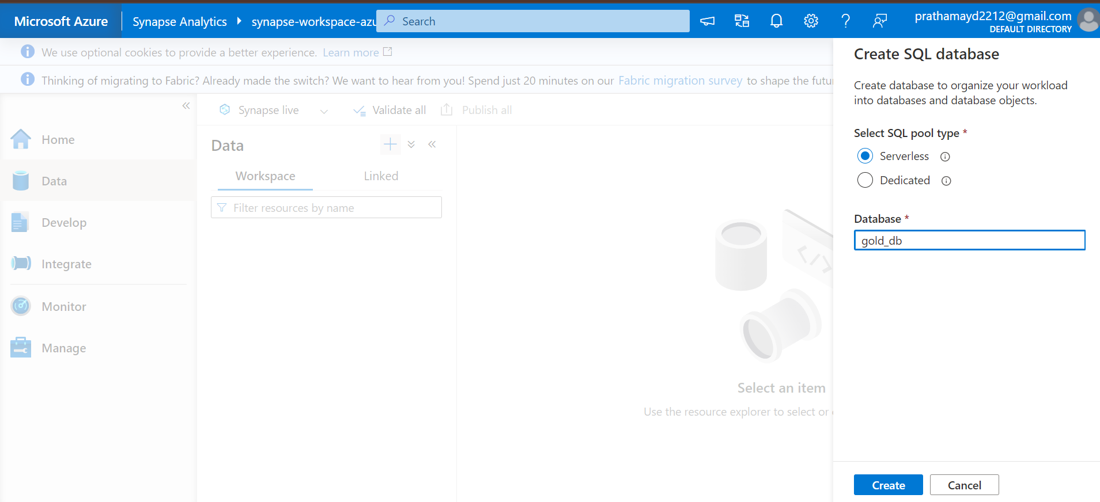

🡪Creating a pipeline that dynamically creates a view of all the tables at once.

Develop tab🡪new 🡪 SQL Script and copy paste the below code:

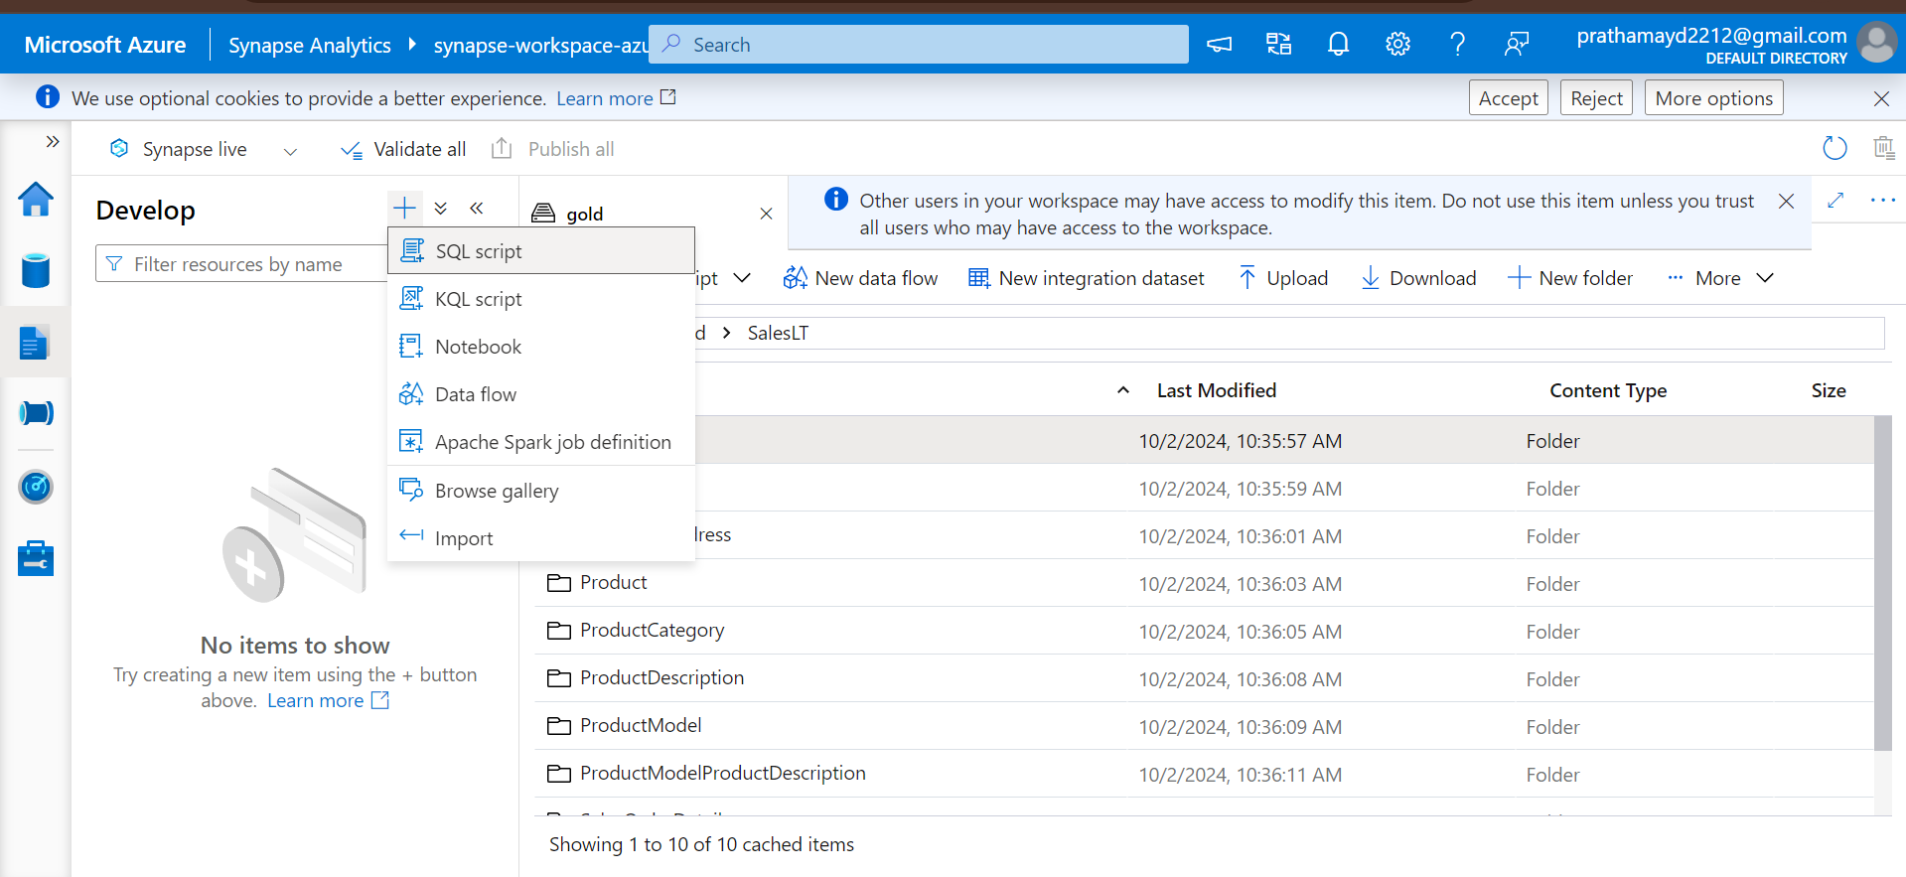

USE gold_db

GO

CREATE OR ALTER PROC CreateSQLServerlessView_gold @ViewName nvarchar(100)

AS

BEGIN

    DECLARE @statement VARCHAR(MAX)

    -- Corrected: Added spaces before and after @ViewName

    SET @statement = N'CREATE OR ALTER VIEW ' + @ViewName + ' AS

       SELECT *

       FROM

            OPENROWSET(

            BULK ''https://pratdatalakegen21.blob.core.windows.net/gold/SalesLT/' + @ViewName + '/'',

            FORMAT = ''DELTA''

        ) as [result]

    '

    EXEC(@statement)

END

GO

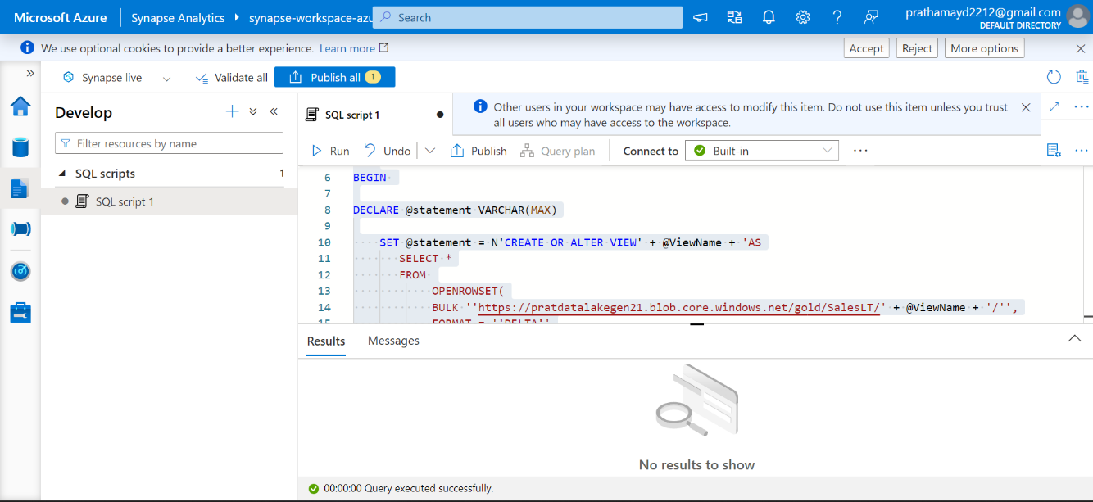🡪Once query is execute successfully, publish all the changes

Now we need to create a linked service to a serverless sql database.

For that we will follow the below steps

Manage>>Linked Service>>New linked service>>Azure SQL Database

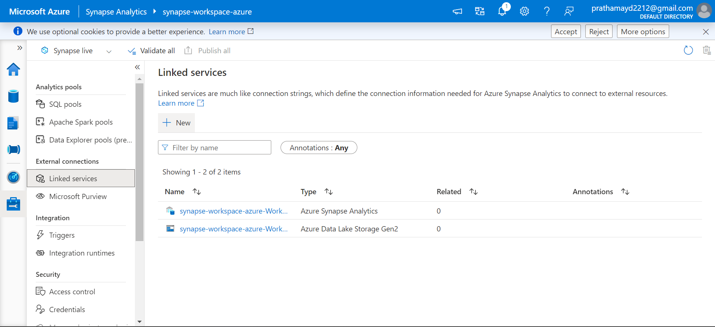

In the linked service you need to choose account selection method as enter manually:

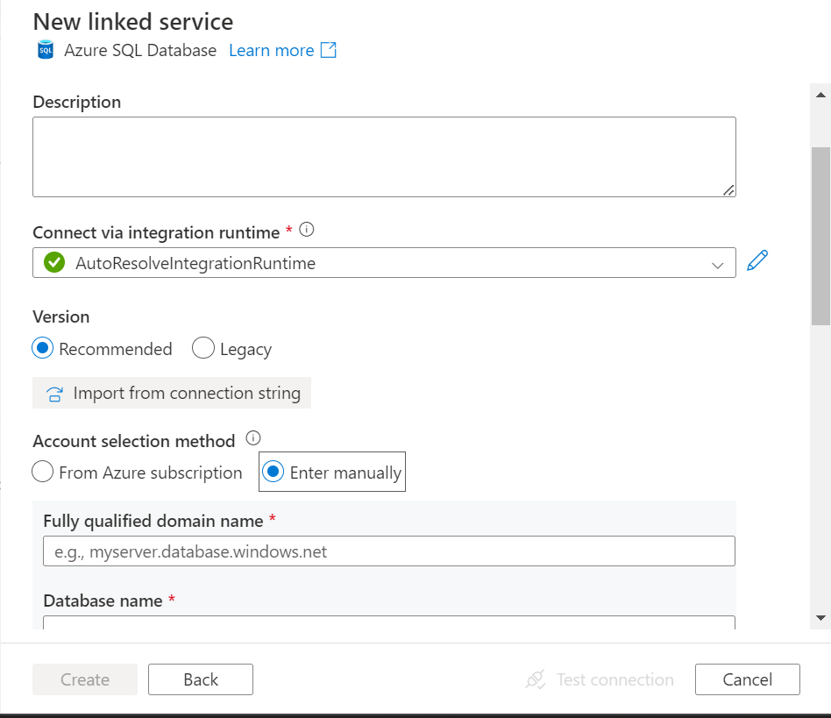

Those details can be derived from the AZURE Synapse workspace 🡪Properties 🡪Sereverless SQL endpoint (Copy that and paste)

Choose sql authentication as **System-assigned managed identity**

**Test connection and create. Then publish the changes**

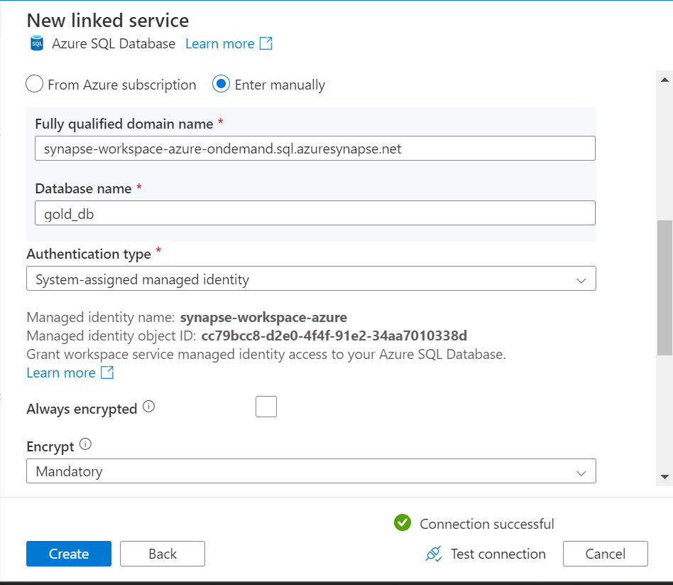

Now go to the integrate tab and create a pipeline.

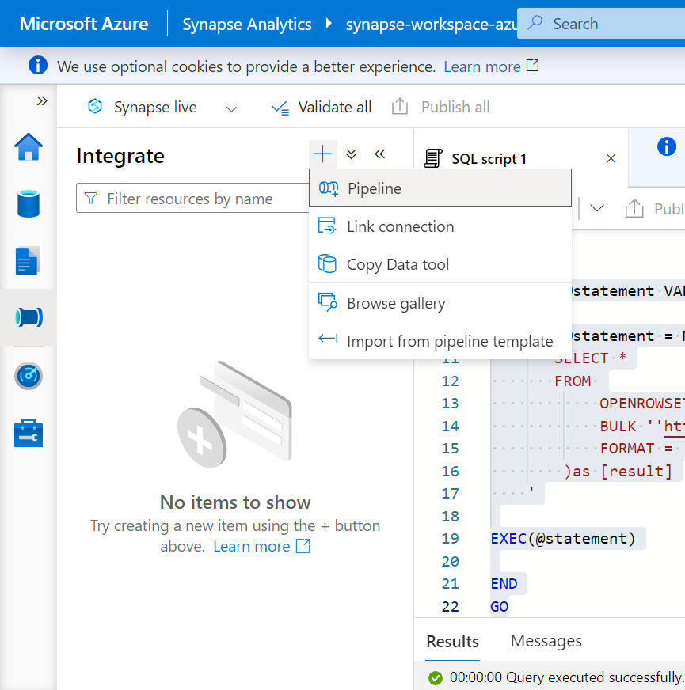

Search for get metadata activity and drag n drop It in the center.

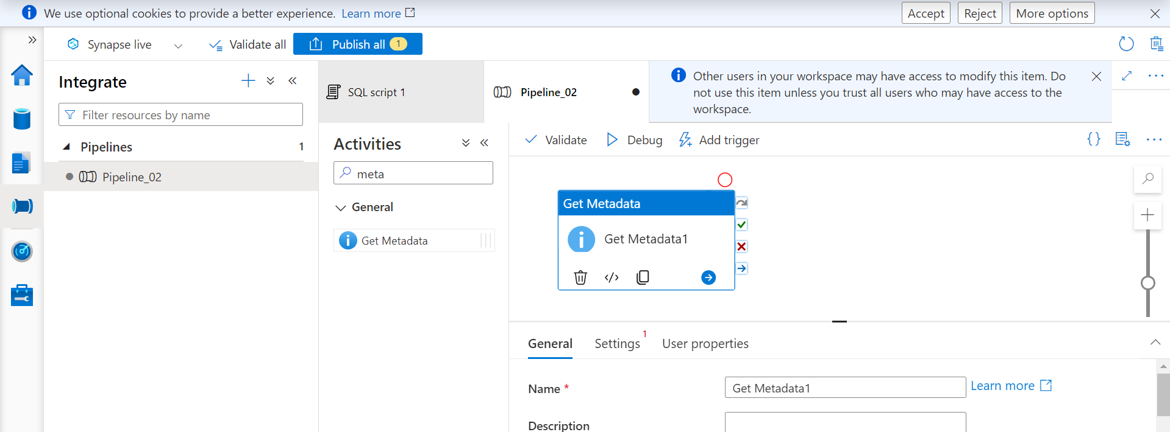

It gets all the table name from the gold coantainer.

Rename the activity to get table names.

🡪Settings and create a new data set for ADLS v2(Azure Data Lake Services v2)

🡪Choose Binary file format

🡪rename service

🡪Attach the default linked service

🡪Choose the SalesLT folder in which all the tables are present.

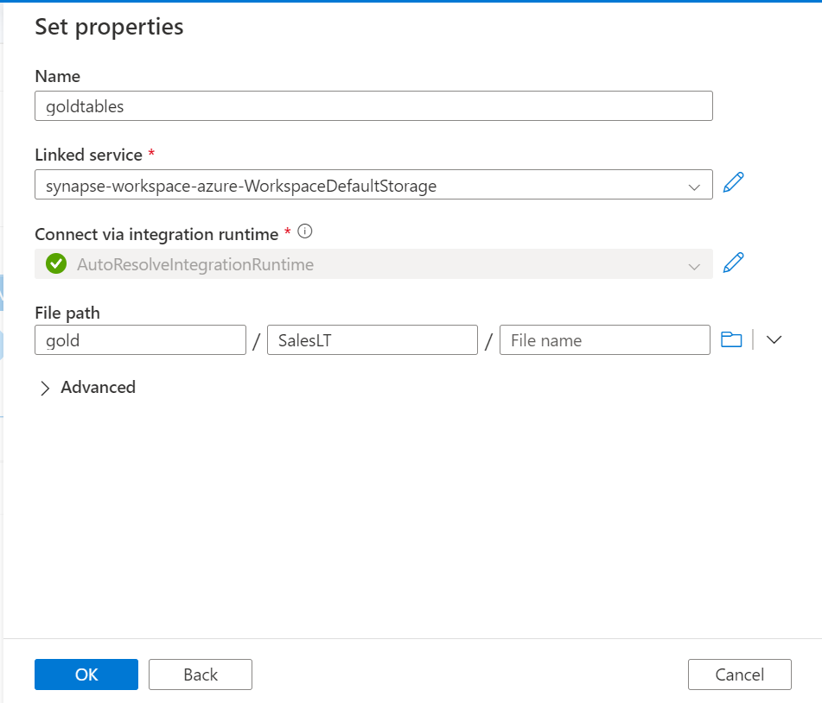

Next:

🡪Field list and add child items to it.

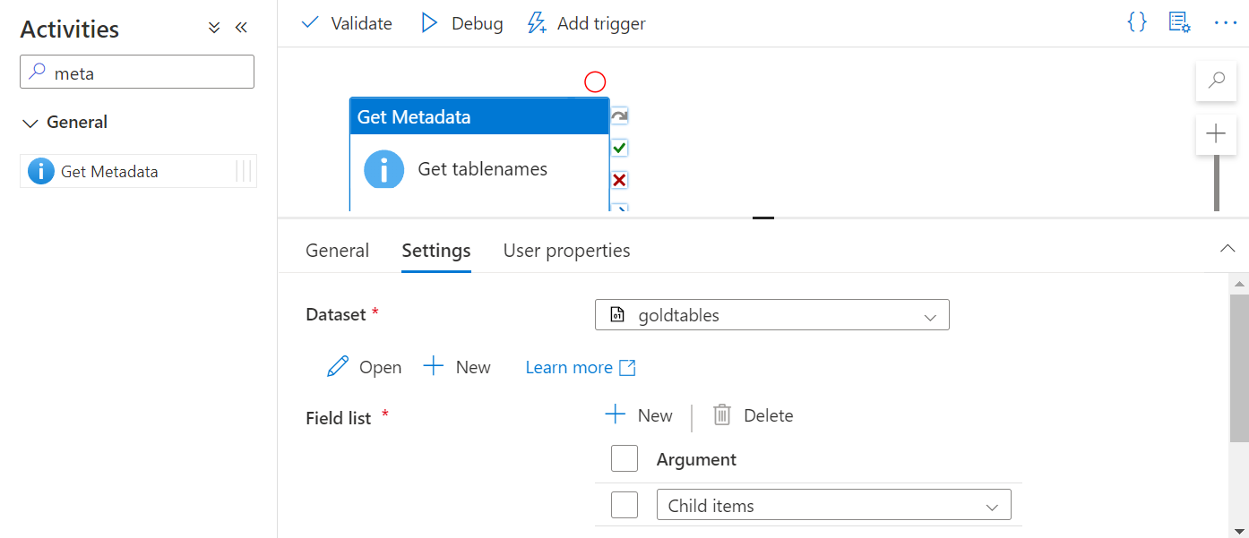

Debug the get metadata activity and then add a foreach activity to it

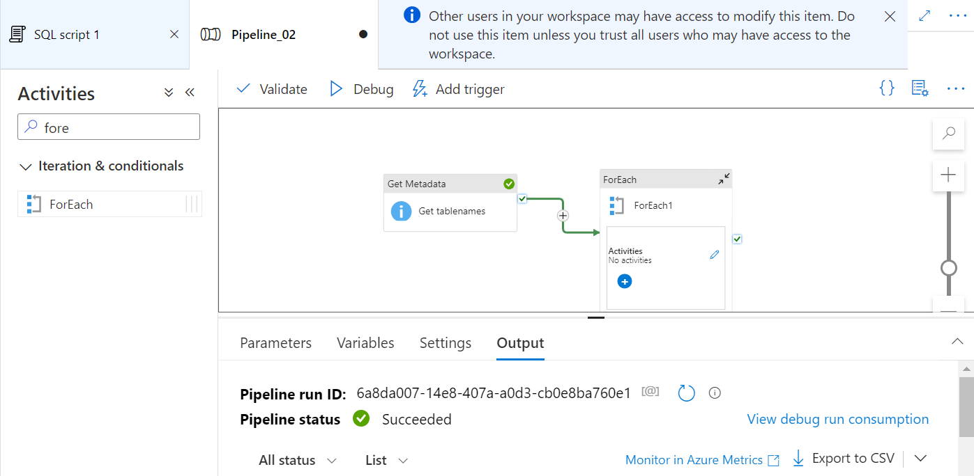

Foreach activity🡪Settings🡪items(Add dynamic content)

And pass the below value(or just click on Get tablenames and add .childItems to it)

@activity('Get tablenames').output.childItems

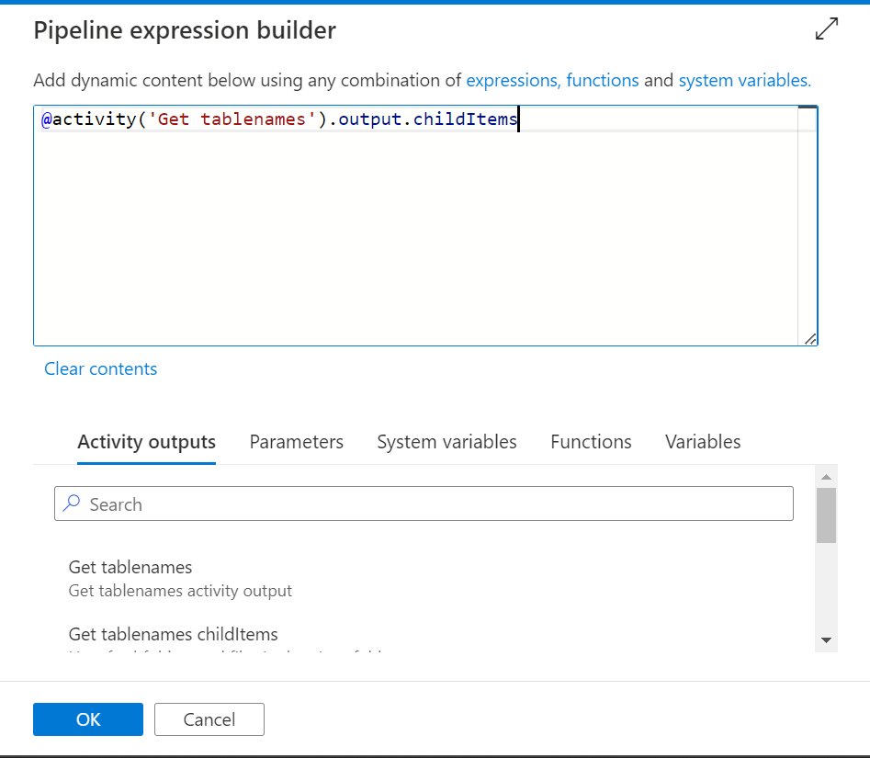

Click ok and save it  
  
Now Foreach 🡪 Activity 🡪 Edit

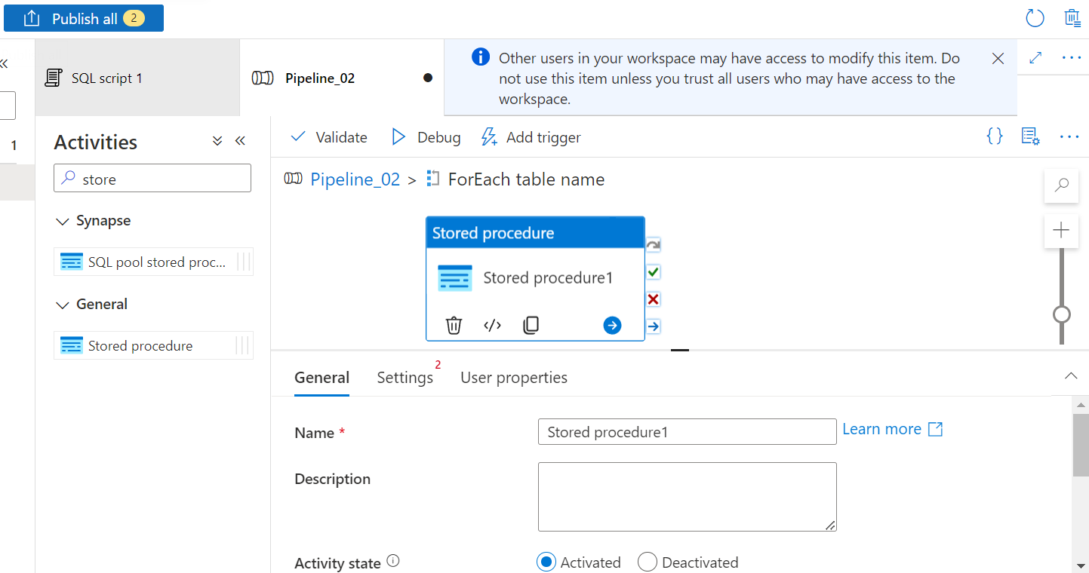Search for stored procedure and drag it in the center.

Now we need to refer to the stored procedure that we have already created.

Stored procedure 🡪 Settings 🡪Link the serverless service 🡪 choose the procedure name🡪 Add parameter

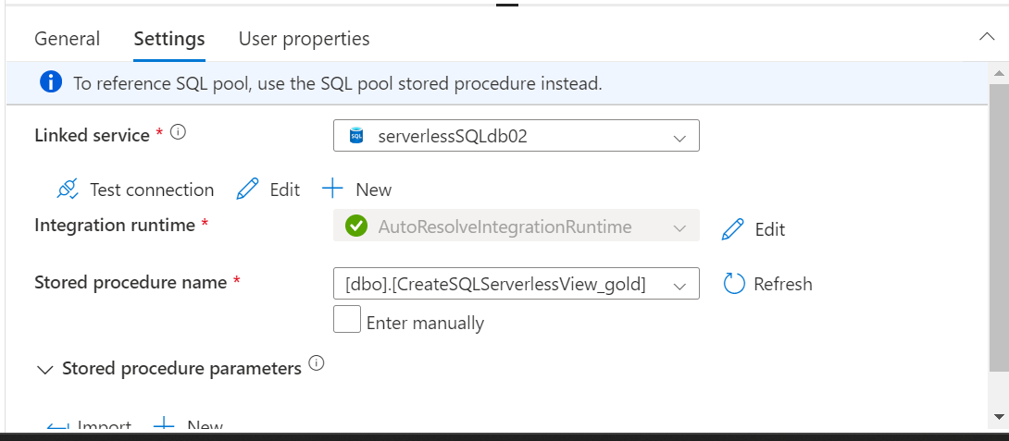

Add the parameters

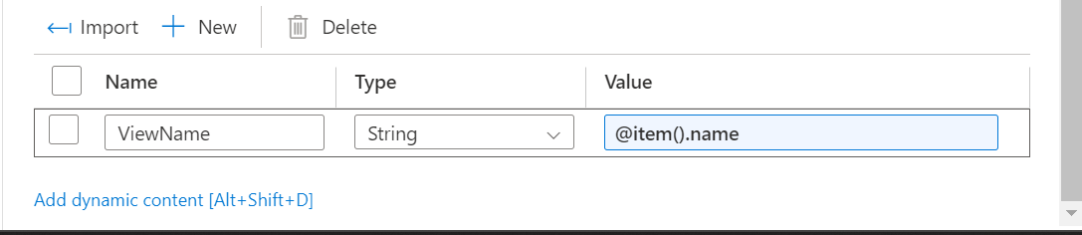

Parameter name is taken from the stored procedure query.

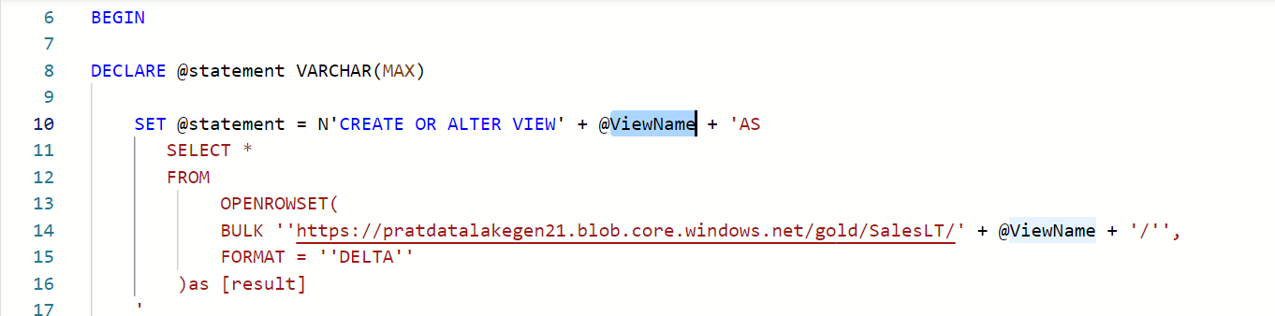

Publish all the changes

And run the pipeline and trigger now.

Once the pipeline run completes successfully you can go to the data tab click on the database(gold_DB) and click on views you will see the table names.

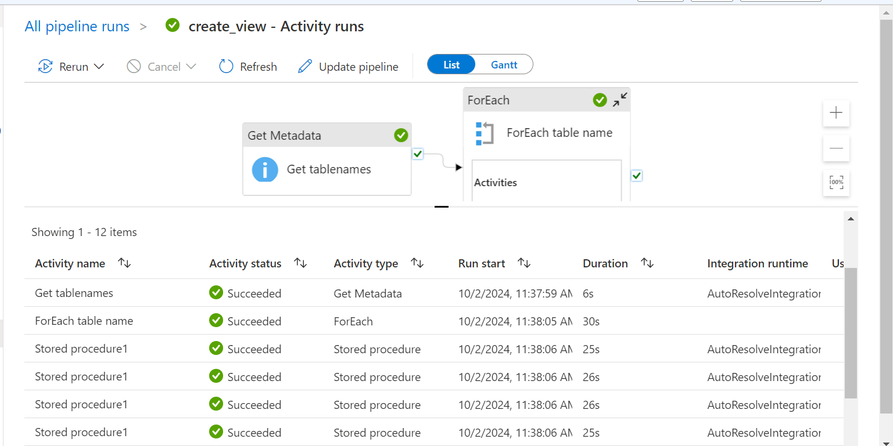

Views:

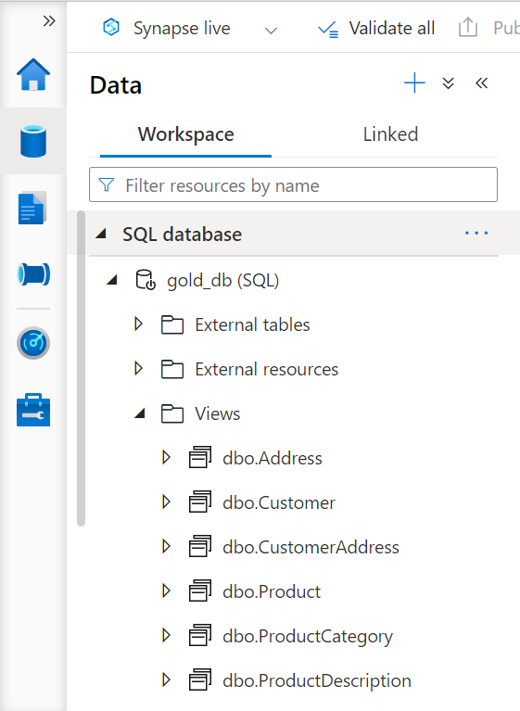

In the next step we will use power BI to fetch the views from synapse and create a report using the same.

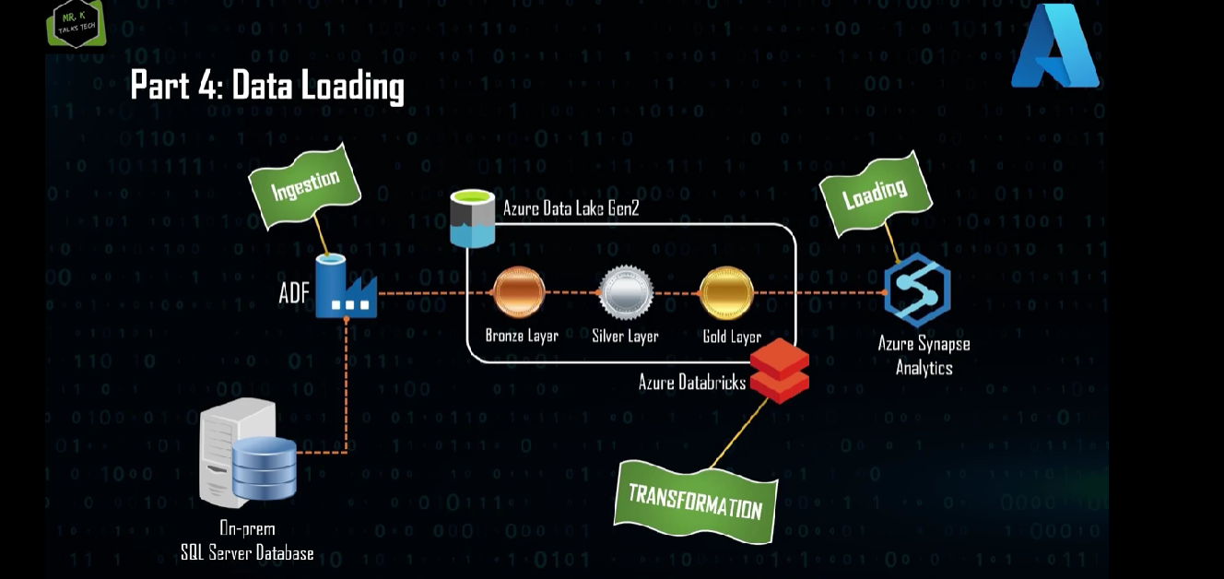

**Reporting**

For reporting we will be using power bi for creating an interactive dashboard.

Open the Power Bi Desktop 🡪Get data 🡪more🡪Azure🡪Azure Synapse workspace.

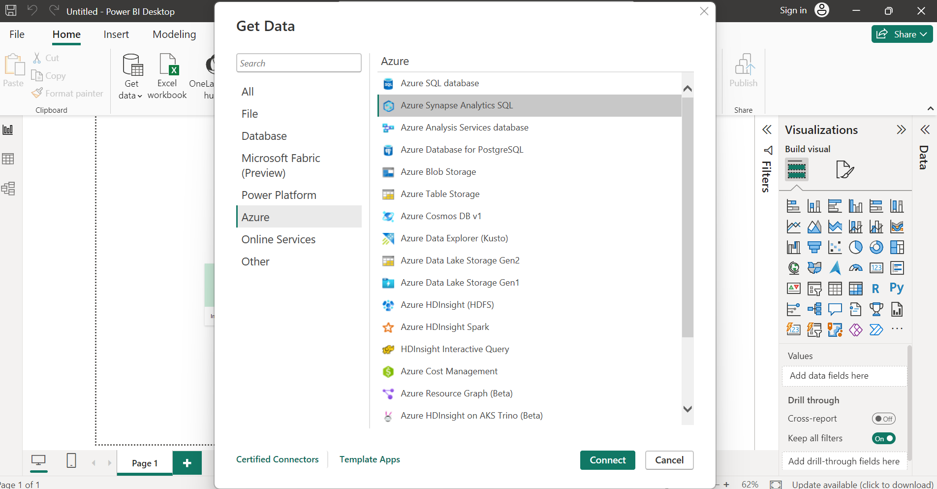

Go to Synapse resource in azure 🡪 properties 🡪 Serverless SQL Endpoint(Copy the url and paste it.)

-Enter the database name(gold_db)

-Import

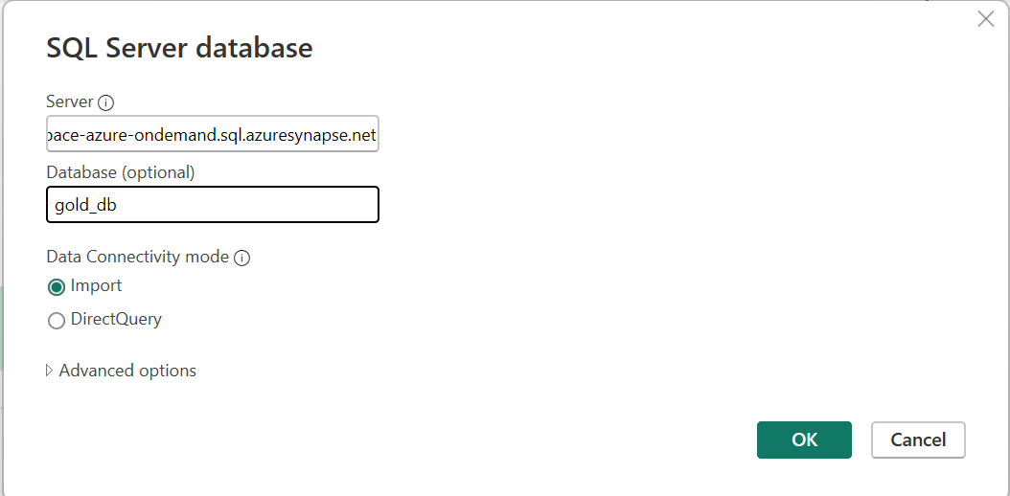

Choose to login with your Microsoft accont:

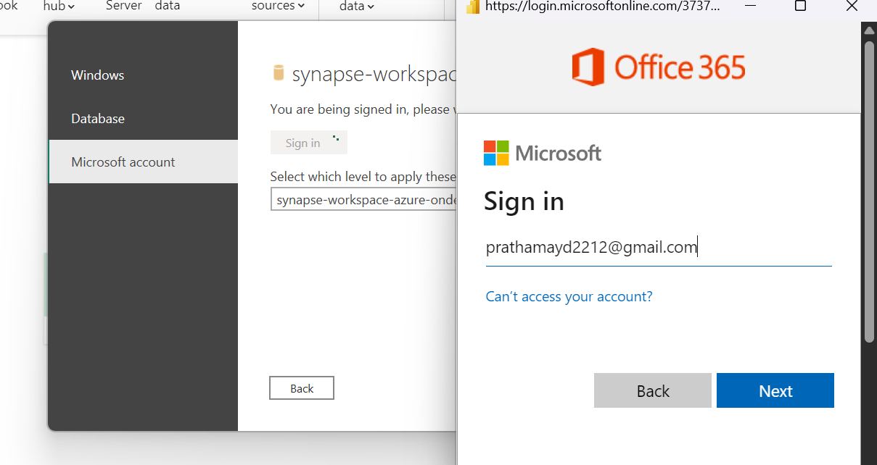

Enter the password🡪Enter the otp and click on connect.

And you will be able to see the list of tables.

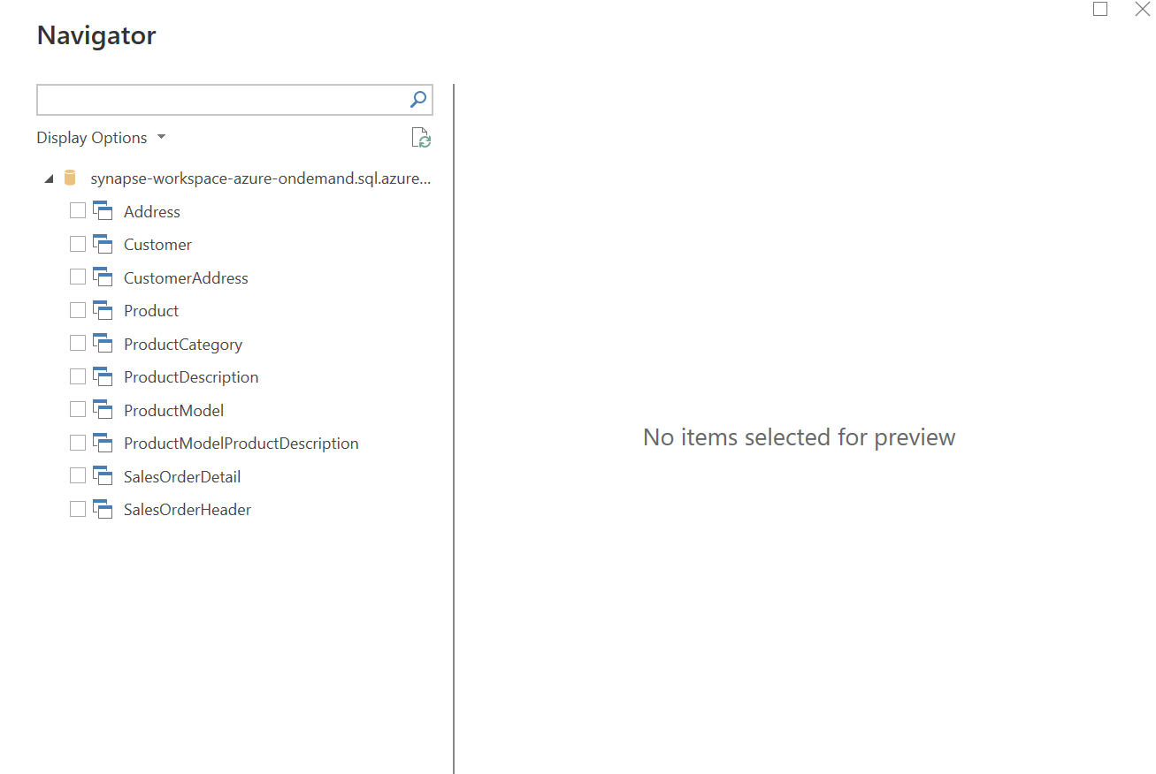

Select All the views and load them in Power BI

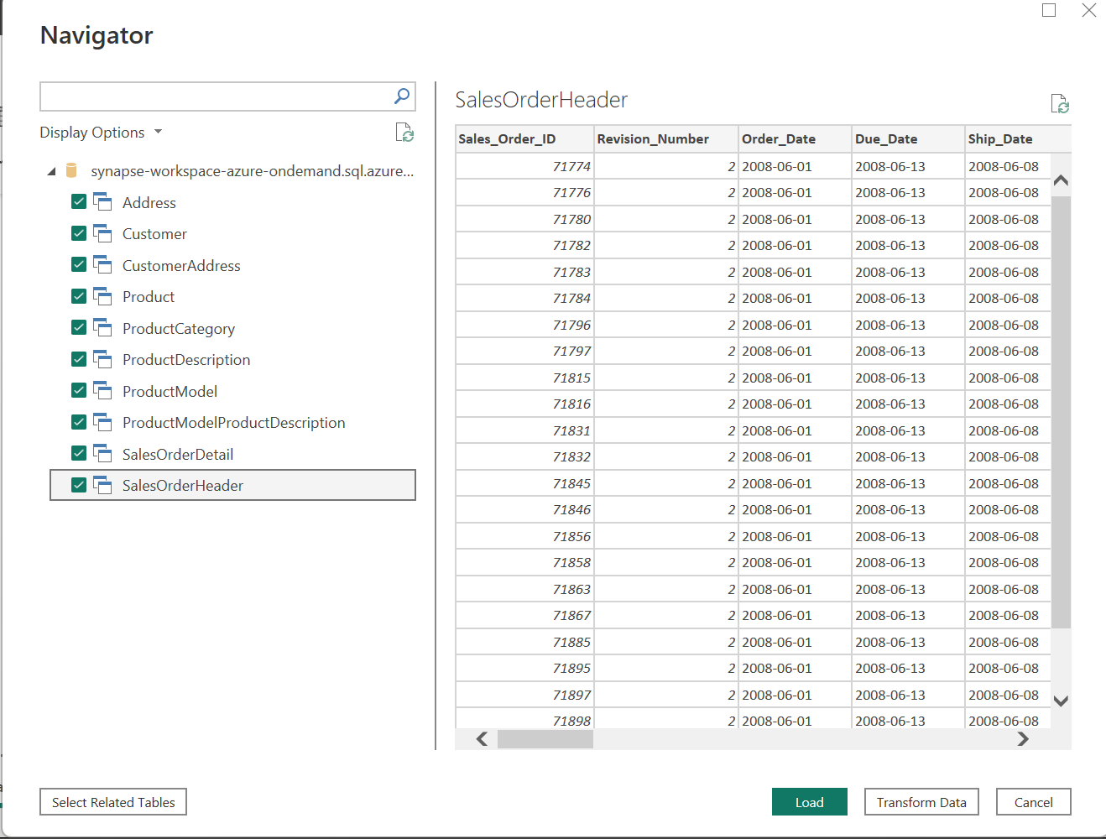

Once loaded you will be able to see all the data in the data section of power bi

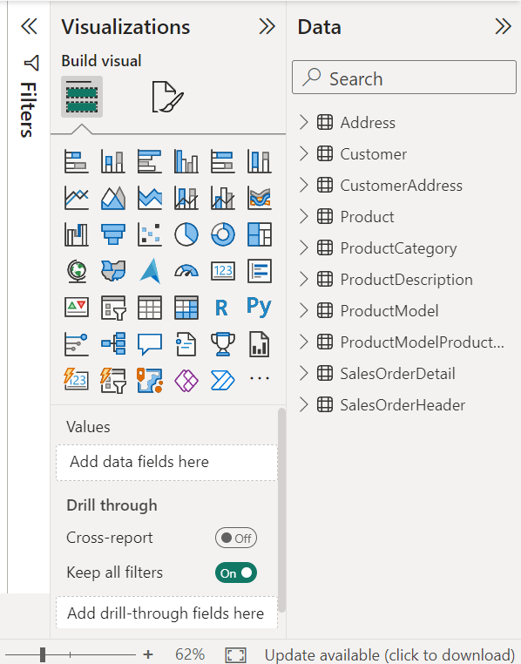

In power Bi go to the data modelling tab and click on Manage relationships to create a proper data model.

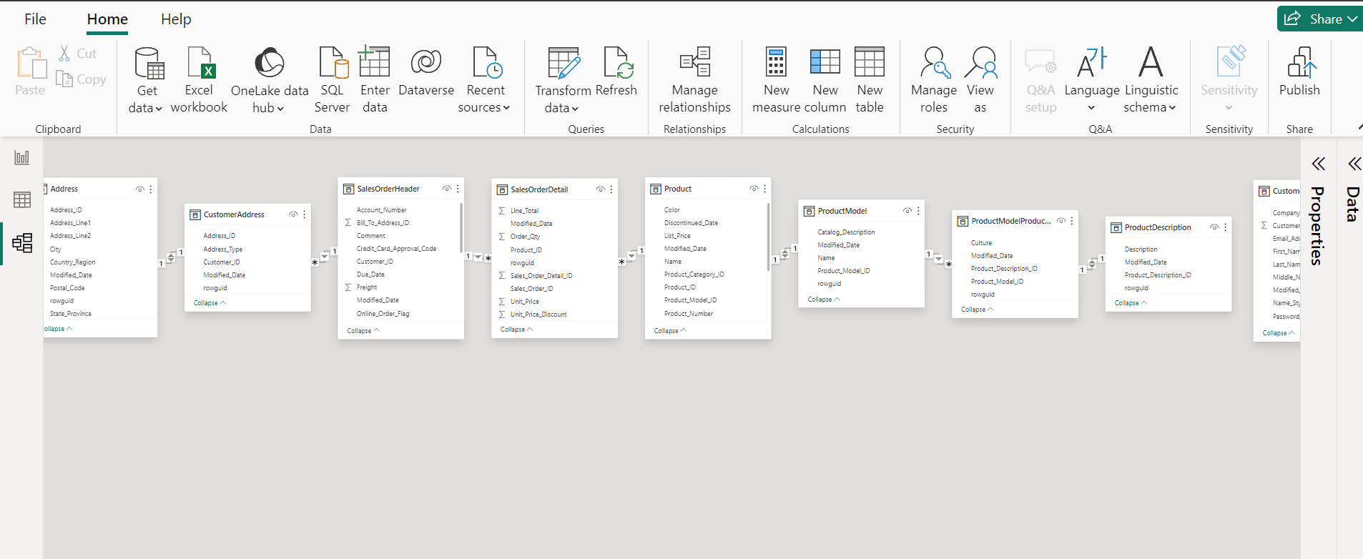

Click on the new tab and create the first relationship.

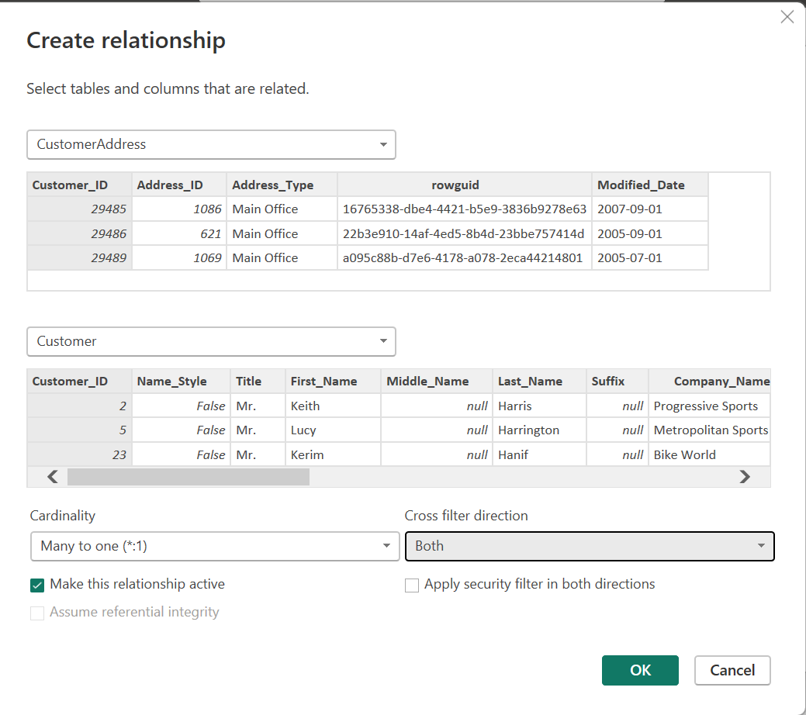

We can do data modelling as shown above.

Once done we will move to the report tab to create a simple dashboard.

Create a card visual and Choose product Id column, drag n drop in the fields.

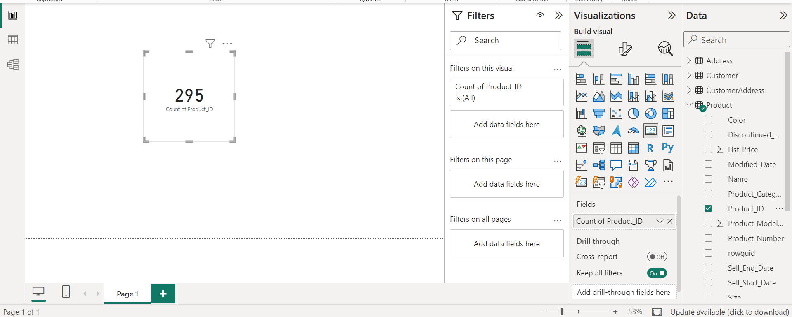

SQL Query to enter more data in a table and test the pipeline.

-- Enable IDENTITY_INSERT for SalesLT.Customer

SET IDENTITY_INSERT SalesLT.Customer ON;

-- Insert records with specific CustomerID values

INSERT INTO SalesLT.Customer

(CustomerID, NameStyle, Title, FirstName, MiddleName, LastName, Suffix, CompanyName, SalesPerson, EmailAddress, Phone, PasswordHash, PasswordSalt, rowguid, ModifiedDate)

VALUES

(30119, 0, 'Mr.', 'John', 'A.', 'Doe', NULL, 'Doe Industries', 'SP-123', 'john.doe@example.com', '555-1234', 'HASH123', 'SALT123', NEWID(), GETDATE()),

(30120, 1, 'Ms.', 'Jane', 'B.', 'Smith', NULL, 'Smith Corp', 'SP-456', 'jane.smith@example.com', '555-5678', 'HASH456', 'SALT456', NEWID(), GETDATE()),

(30121, 0, NULL, 'James', 'C.', 'Johnson', 'Jr.', 'Johnson Ltd.', 'SP-789', 'james.johnson@example.com', '555-7890', 'HASH789', 'SALT789', NEWID(), GETDATE());

-- Disable IDENTITY_INSERT after inserting records

SET IDENTITY_INSERT SalesLT.Customer OFF;